Apply to join North Yorkshire Local Access Forum  Speak up on Countryside Access | 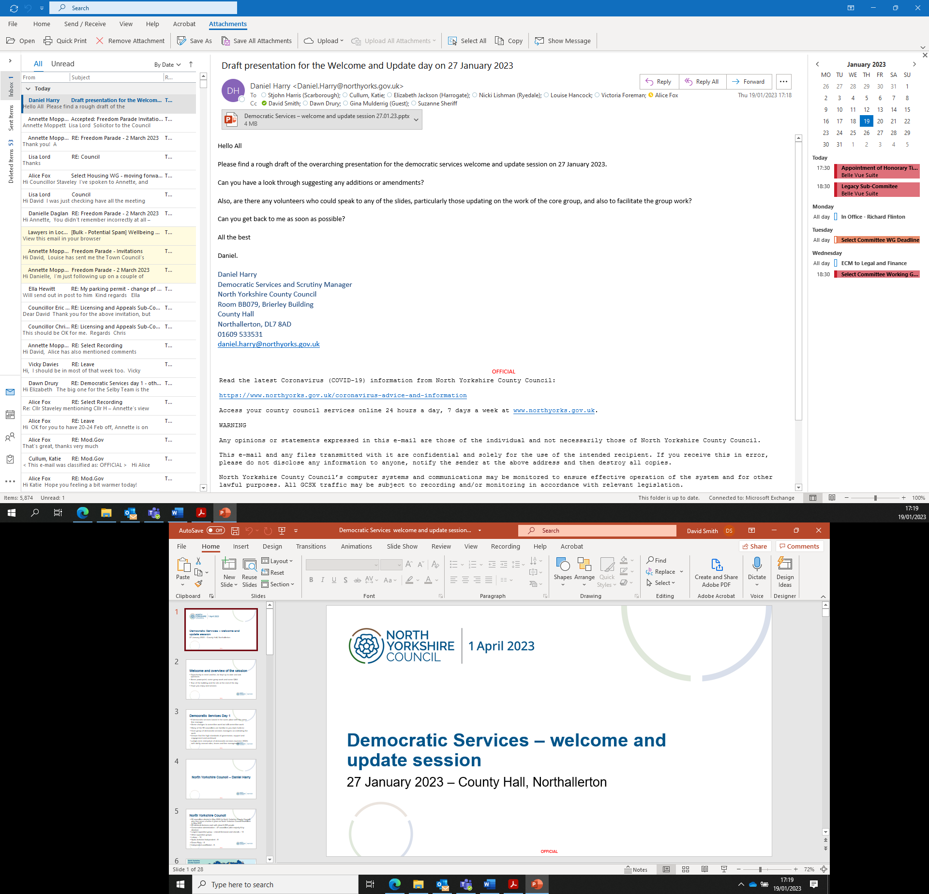

Are you:
- Interested in rights of way and green spaces to explore and enjoy the countryside?
- Keen to help shape the future of rural and urban paths, and open access land?
- Able to represent landowners and managers, or access users, or other interests?
- Able to spare a morning every four months or so?

Apply to join the North Yorkshire Local Access Forum

North Yorkshire Local Access Forum are currently recruiting new members. People with a passion for the countryside and an interest in exploring their neighbourhoods are invited to apply.

The Forum is an independent body that advises North Yorkshire Council, and other relevant bodies, on how people can make the most of opportunities for getting out and about in the great outdoors. It brings together representatives of land managers, users and other relevant fields or areas of interest to watch over and help shape the future of footpaths, bridleways, byways, open access land and other green spaces within North Yorkshire outside of the boundaries of the two National Parks.

To ensure the Forum represents the varying aspects of ‘access’ both to the countryside and in urban areas, applicants are sought who are interested in any of the following:

- Walking and Rambling | - Land Owners, Managers and Farming
- Running and/or Orienteering | - Nature Conservation and Environment
- Cycling and Mountain Biking | - Rural / Local Business
- Equestrian pursuits (riding or driving) | - Tourism
- Motorised vehicle and motor bike use | - Health promotion
- Water based activities and sports | - Education
- Youth Services / Organisations | - Local Authority
- Disabled and Disadvantaged Groups | - Public Transport
- Ethnic Minority Communities

If you feel that, in a voluntary capacity, you could contribute to the Forum’s work, then please apply online here:– https://nycjobs.engageats.co.uk/Vacancies/W/8575/0/434377/20303/local-access-forum-volunteer

If you have any queries then please contact Dawn Drury, Democratic Services Officer, by email dawn.drury@northyorks.gov.uk or by telephone, 01757 292065.

The closing date for applications is 23 August 2024 at 5pm, with interviews to be held on 5 September 2024. A new member induction session will take place in mid-September 2024.

